TITLE MUST BE TYPED WITH CAPITAL LETTERS, A 14-POINTS TIMES NEW ROMAN BOLD AND CENTERED

Name surname 1^{1*}, Name surname 2^{1,2}, and Name surname 3¹ (Please underline presenting author)
The author's name(s) should be typed with 9-point Times New Roman and centered

¹ Affiliation for first author (Department, Institution, address, postal code and city, country),
² Affiliation for second author, … (Department, Institution, address, postal code and city, country)
(The author’s affiliation(s) should be centered and in 9-points Times New Roman italic.)

*Corresponding Author’s E-mail: xxexample@xxx.com (9-point Times New Roman and centered)

ABSTRACT
Text must be typed with a regular type 11-point Times New Roman, single spacing. Alignment must be formatted to full justification (left and right flushed). It is recommended that the author use this template to prepare the abstract. The A4 paper size (21cm x 29.7cm or 8.27" x 11.69") must be used. Abstract information must not appear outside the margins. The abstract should be between 80 and 250 words in one paragraph (including introduction, objectives of the study, methods, results, and conclusions). Abbreviations must be defined, by placing them in parentheses after the full word, the first time they appear. Use numerals to indicate numbers except when beginning sentences. Nonproprietary (generic) names, written in lower-case letters, are required the first time a name is mentioned. Proprietary names must always be capitalized. Note; for the review process leave the author/affiliation section as is.

Keywords: word1, word2, word3 (not more than 5 items and must be typed with a regular type 11-point Times New Roman) Alignment must be formatted to full justification.

INTRODUCTION
Text must be typed with a regular type 10-point Times New Roman, single spacing. Right margins should be justified, not ragged.

PAGE SIZE
All material on each page should fit within a rectangle of 17 × 25 cm, centered on the page. The page layout should be set as moderate margin (top & bottom: 2.54 cm, right & left: 1.9 cm). The A4 paper size must be used. The text should be in two 8.15 cm columns with a 0.9 cm gutter.

TYPESET TEXT

Subsequent Pages
For pages other than the first page, start at the top of the page, and continue in double-column format. The two columns on the last page should be as close to equal length as possible.

References and Citations
The references are also Times New Roman 10-points. References should be published materials accessible to the public. Use the Vancouver reference style for references – that is, a numbered list at the end of the article, ordered alphabetically and formatted accordingly. Word may try to automatically ‘underline’ hotlinks in your references, the correct style is NO underlining.

Page Numbering, Headers and Footers
Do not add headers, footers or page numbers in your submission. These will be added when the publications are assembled.

FIGURES/CAPTIONS
Place Tables/Figures/Images in text as close to the reference as possible (see Figure 1). It may extend across both columns to a maximum width of 17 cm.
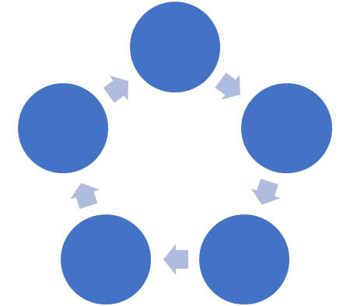
Figure 1. Insert caption to place caption below figure.

Captions should be Times New Roman 9-point bold. They should be numbered (e.g., “Table 1” or “Figure 2”), please note that the word for Table and Figure are spelled out. Figure’s captions should be centered below the image or picture, and Table captions should be centered above the table body.

Table 1. Table captions should be placed above the table
Topic | A | B | C
Tables | Frist | Second | Third
Figures | Good | Similar | Very well

SECTIONS
The heading of a section (e.g. introduction, objectives of the study, methods or methodology, results, discussion and limitation, and conclusion) should be in Times New Roman 12-point bold in all-capitals flush left. Sections and subsequent sub- sections should be numbered and flush left. For a section head and a subsection head together (such as Section 3 and subsection 3.1).

Subsections
The heading of subsections should be in Times New Roman 12-point bold with only the initial letters capitalized. (Note: For subsections and subsubsections, a word like the or a is not capitalized unless it is the first word of the header.)

Subsubsections
The heading for subsubsections should be in Times New Roman 12-point italic with initial letters capitalized subsubsections.

ACKNOWLEDGMENTS

REFERENCES
- Use the Vancouver reference style for references
- …

